

**USER MANUAL**

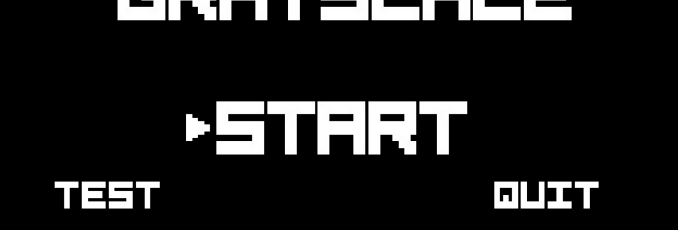

# Starting out

When you start up the game, you will be prompted with a menu with three different options: Start, Extras, and Quit.

* Start: Begins the game.
* Test: Test whether game is working properly. For devs/graders.
* Quit: Closes the game.

Navigate the menu by pressing the “W” and “S” keys. Press down the spacebar key to select an option.

The “shift” key will invert the color scheme of the menu. We’ll get back to this later though.

# Movement

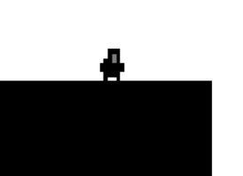

Moving is very important if you want to improve your score. You can dictate Grayman’s lateral movement by pressing the “A” and “D” keys on your keyboard.

# Jumping

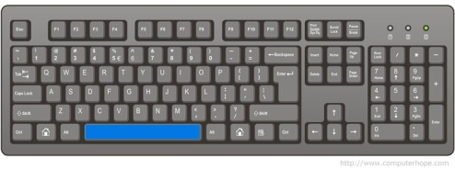You can make Grayman jump in the air by pressing the spacebar key.



# Air Movement

****You can also control Grayman’s movement in the air by using the “A” and “D” keys. Very useful for when you’re just inches away from a platform.

# 

You must jump in order to grab the coins.

# Coins

Collect coins by jumping into them. Collecting coins will boost your score.

# High Scores

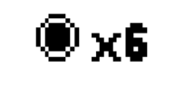

Your high score will be displayed at the top right of the screen.

Meanwhile, your distance traveled will be displayed at the top left of your screen. There are separate high score categories for coins collected and distanced traveled.

# Death

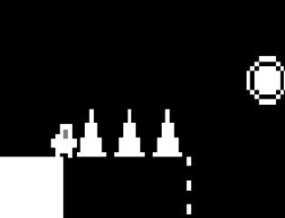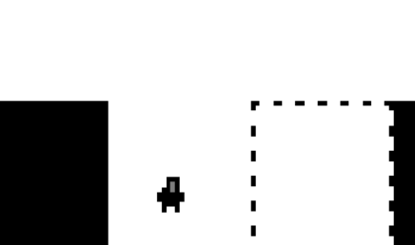Death is an unfortunate subject for Grayman- he dies a lot. Grayman’s most common cause of death is falling off the platform and into the abyss known as “the shadow realm”. Be cautious of where you jump though- Grayman can also die by running into spikes that are the same color as him.

Uh-oh

Not again :(

In order to boost your high score, it is beneficial and necessary to keep Grayman alive for as long as possible.

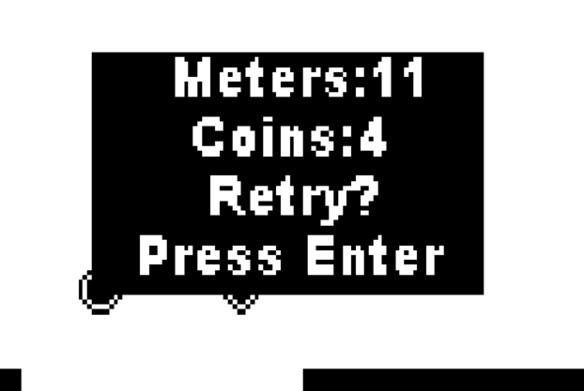

Upon death, your score and distance traveled will be displayed. You can play again by pressing the enter key.

# Shifting

# 

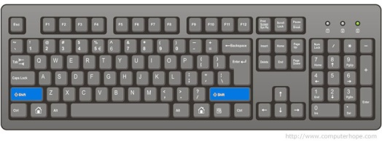



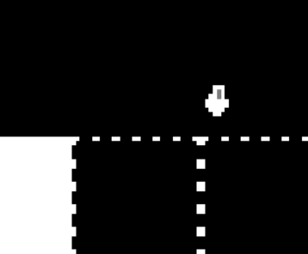Pressing either one of the shift keys will result in Grayman’s world inverting colors. Grayman can only step on solid (not dashed) areas of land that are the same shade as him.

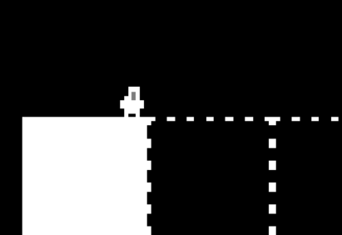

Not Okay!

Okay!!

# Test Suite



The test suite is designed for devs and graders to assure that the game is working as it should be.

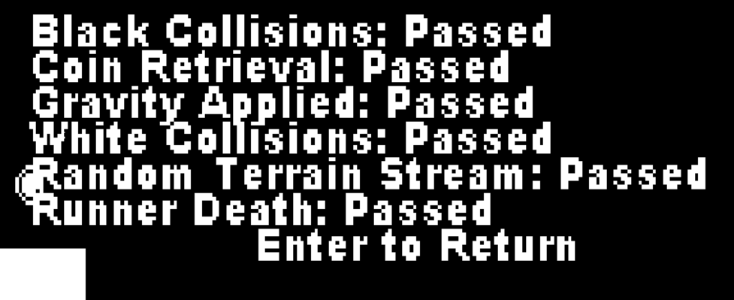

The test suite tests multiple parts of the code, including black and white terrain collisions, random terrain stream generation, coin generation and retrieval, gravity, and death.

Thanks and have fun playing our game!

-GitsOutForHarambe